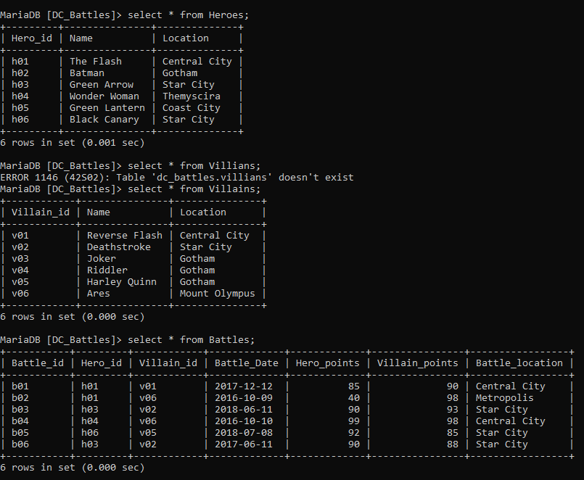

A:

select Heroes.name, avg(Battles.Hero_points)

-> from Heroes

-> Join Battles on Heroes.Hero_id = Battles.Hero_id;



B: